**Table of Content for  
The Project Plan**

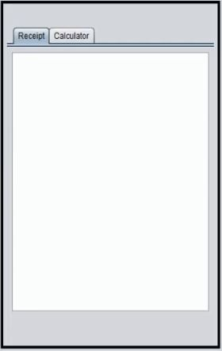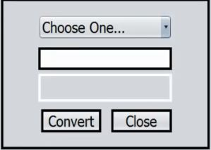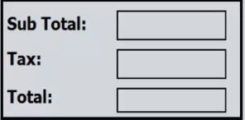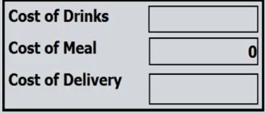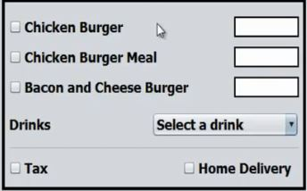**1. Project Resources :**  
1.1 The restaurant staff is our customer.  
1.2process description.

**3. panel to calculate entire cost including tax.**

**2. panel To calculate the cost.**

**1**. **-** **enter number of meals.** -**select a drink ,tax , home delivery.**

1.3 Technologies: Java programming language .

**6. Buttons to execute some functions.**

**5. here is a panel to show the receipt and calculator.**

**4. panel to convert price**

Tools: NetBeans .

**2.Prouduct /Study Dairy :**

2.1 Roles and Responsibilities:

Both roles and responsibility are include in excel sheet, it those are screen shot to it:

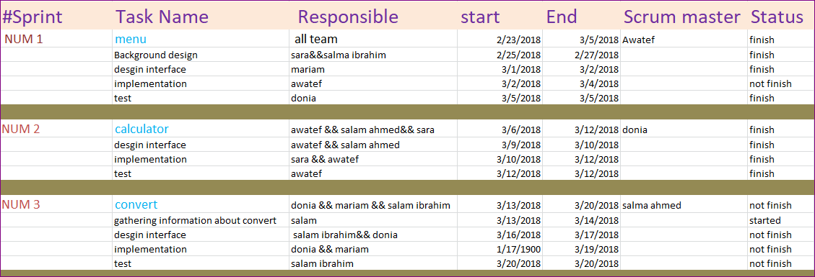

**3. Risk Management Plan :**

As software engineers, we have faced risks in implementing our project

There are two types of risks that you may face

**First: Collective risks:**

The risks that meet time in the course of a worker

1 - Adding Mutations: During the pool one can add an option that facilitates the operation of the software. The client does not need this functionality

2. Continuous development: Tim's inability to adapt to technology development may cause Tim's inability to deliver the project on time

3 - the emergence of something basic essential minus: I want to start work again

**Second, individual risks**

**Risks faced by the software engineer alone**

1 - Wrong estimate of time: that the Task fixed by a certain time and takes more time than his time Daoudi to delay things in the project

2 - Knowledge: The lack of interest in the individual in the task of what was implemented in the initiation will lead to the inefficiency of his job

|  |  |
| --- | --- |
| Events | Schedule |
| Project set-up and roles assigned. 1st Sprint. Reserved sprint review meeting for Sprint1. | **ByThu22.2**  **Thu1.3. – Wed14.3.**  **ByFri6.3** |
| Sprint review meeting for Sprint1. 2nd Sprint. Reserved sprint review meeting for Sprint2. | **ByFri9.3-Sun11.3**  **Thu15.3. – Wed28.3.**  **ByTue20.3** |
| Sprint review meeting for Sprint2. 3rd Sprint. Reserved sprint review meeting for Sprint3. | **ByFri23.3-Mon26.3**  **Thu29.3. – Wed18.4.**  **ByFri6.4** |
| Sprint review meeting for Sprint3. 4th Sprint. Reserved sprint review meeting for Sprint4. | **ByTue10.4-Sun15.4**  **Thu19.4. – Fri18.5.**  **BySun22.4.** |
| Sprint review meeting for Sprint4. Presentation of the project. | **Thu26.4. – Sun29.4.** **Thu10.5.** |

**Project Schedule**

**Project Plan**

**User Stories**

As a user,

I want to start over,

To make order correct .

As a user,

I want to change currency,

To corresponds to several currencies.

As a user,

I want to close the system

To finish my work.

As a user,

I want to calculate,

To figure some bills

As a user,

I want the entire price,

To save calculation time.

As a user,

I want options,

To select the order.

**2. Sprints schedule, Ideal weeks, Fudge factor , Project velocity :**

|  |  |  |  |  |
| --- | --- | --- | --- | --- |
| sprints | Schedule | Ideal week | Fudge Factor | Project velcoity |
| 1. Project set-up and roles assigned | ByThu22.2  Thu1.3. – Wed14.3.  ByFri6.3 | 2 weeks | 3 days | In The first day ; project velocity is 5 hours…  In the last day is 3 hours |
| 1. Creating panels and design | ByFri9.3-Sun11.3  Thu15.3. – Wed28.3.  ByTue20.3 | 2 weeks and 3 days | 4 days | In The first day ; project velocity is 5 :30 hours…  In the last day is 3:20 hours |
| 1. Adding code to make it work | ByFri23.3-Mon26.3  Thu29.3. – Wed18.4.  ByFri6.4 | 3 weeks | 5 days | In The first day ; project velocity is 4 hours…  In the last day is 2hours |
| 1. Test the entire program | ByTue10.4-Sun15.4  Thu19.4. – Fri18.5.  BySun22.4. | 2 weeks and 4 days | 6 days | In The first day ; project velocity is 6 hours…  In the last day is 1:30 hours |
| 1. see the user’s opinion and if the user want some modifications | Thu26.4. – Sun29.4.  Thu10.5. | *2 weeks* | *3 days* | In The first day ; project velocity is 4 hours…  In the last day is 2:30 hours |

**Imagine scenario**

* **First scenario:**

In the middle of the project, we imagine that the tester may tell us

His opinion for adding or removing some steps or he may

Find difficulty in design for the user so that we have to

Modify these things to simplify the use of system for the user.

* **Second scenario:**

In the middle of the project, we imagine that we may spend more

Time at first so that we may can’t finish the project at the time so we

Should put ourselves under pressure for finishing at the time that has

Determined.